The 2011 Li’i Pearl Outstanding Student Award

Named in honor of Julia Keali’ikahikookalani ‘Li’i’ Pearl, the Li’i Pearl Outstanding Student Award honor a student who has made special contributions to the department, the school, the university, and the community at large and serves as "proud representative" of the Department of English. This is the fourth year for the Li’i Pearl Awards
The Li’i Pearl Award Winners

Adam Smith

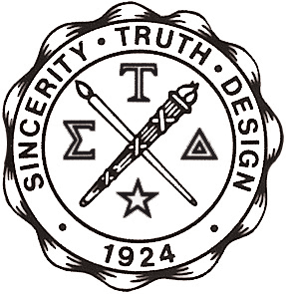

http://www.english.org
http://www.csub.edu/englishclub

The 2010 Li’i Pearl Outstanding Student Awards

Named in honor of Julia Keali’ikahikookalani ‘Li’i’ Pearl, the Li’i Pearl Outstanding Student Awards honor students who have made special contributions to the department, the school, the university, and the community at large and serve as "proud representatives" of the Department of English. This is the third year for the Li’i Pearl Awards.

The Li’i Pearl Award Winners

Lauren Abel ♦ Alise Aycock ♦ Kshiti Vaghela

http://www.english.org
http://www.csub.edu/englishclub

