Sigma Tau Delta

Sigma Tau Delta, the International English Honor Society, was founded in May 1924 at Dakota Wesleyan College in Mitchell, South Dakota, by Professor Judson Owen. Its central purpose is to confer distinction upon outstanding students of the English language and literature in undergraduate, graduate, and professional studies. Sigma Tau Delta also recognizes the accomplishments of professional writers who have contributed to the fields of language and literature.

The name Sigma Tau Delta comes from the Greek letters representing the first letter of each of the words that form the official motto, Sincerity, Truth, Design. The official colors of the society are cardinal and black; the official flower is the red rose. The official seal can be found on all official documents of the society:

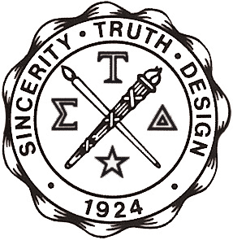

Through the work of chapters on the campuses of more than five hundred colleges and universities, Sigma Tau Delta provides exceptional students with opportunities for advancing the study of language and literature, for developing skills in creative and analytical writing, and for meeting other scholars and professionals in the discipline of English.

Members of Sigma Tau Delta also have the opportunity to publish their writing in the organization’s literary publication, The Rectangle, and student members are eligible to compete for a number of writing awards. In addition, student members may receive international recognition through academic scholarships, professional internships, and teaching awards. At regional conferences and at the annual international convention, students may present original and analytical work and network with students, faculty, and professionals from around the world.

CSUB English Club

An offshoot of the Xi Tau chapter of Sigma Tau Delta, English Club engages in social activities and attempts to promote the English major as a course of study conducive to fulfilling the goals of an intelligent, well-read, and democratic society.

Evening Program

6:00 pm – Welcome

6:15 pm – 7:00 pm – Dinner

7:00 pm – 7:30 pm – New Member Induction

7:30 pm – 7:45 pm – Presentation of Awards

7:45 pm – 8:30 pm – Installation of New Chapter Officers

New Inductees for 2010/2011

Lauren N. Abel Jonathan Barrett
Jeanne Marie Benabides Sergio Guadalupe Espain
Alyssa Fechner Mike Joseph Figueroa, IV
John Frusetta Mariana Garcia
Denise Hanson Nicholas Allen Harl
Lori Henderson Rebekah Christine Kearn
Katherine Elizabeth Kiramis Katie Elizabeth Lords
Dahna L. Rasmussen Vanessa Rojas
Eduardo Sandoval Stephen Simpson
Ashley Claire Smith Amy Lynn Spoelstra
Sarah Teeters Lizbett Tinoco

Executive Board for 2011/2012

President: Jeanette O'Neill
Vice President: Mariana Garcia
Secretary: Rosa Brown
Treasurer: Katie Lords
Public Relations Officer: Drew Hallum
Historian: Sergio Espain
Antelope Valley Liaison: Amy Spoelstra

