A Look Back/A Look Ahead:

Sigma Tau Delta continues to devote itself to being an active campus leader. In November, we sponsored a presentation by the 2013 Runner Reader author Rebecca Skloot, author of The Immortal Life of Henrietta Lacks, in support of CSUB’s First-Year Experience program. The California Writers Series continued again this year, with poet and novelist Clarence Major and novelist Marisa Silver (part of The Grapes of Wrath 75th Anniversary events). This year also saw the continuation of the Lectures in Language and Linguistics Series, with guest speakers Dr. Robert Podesva, Dr. Robert Kennedy, and Dr. Chris Golston (upcoming on May 8th). We look forward to the ongoing growth of our beloved organization again next year as we continue to sponsor the CWS, the L³, and the 2013 Runner Reader keynote address by Sonia Nazario, author of Enrique’s Journey on October 30th, 2014.

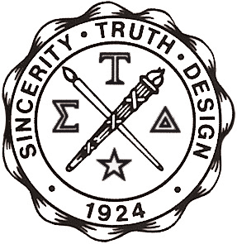

http://www.english.org
http://www.csub.edu/englishclub

Sigma Tau Delta

The International English Honor Society

AND THE CSUB
ENGLISH CLUB

Present

THE THIRTEENTH ANNUAL
INDUCTION AND AWARDS CEREMONY

APRIL 24, 2014

CALIFORNIA STATE UNIVERSITY BAKERSFIELD

