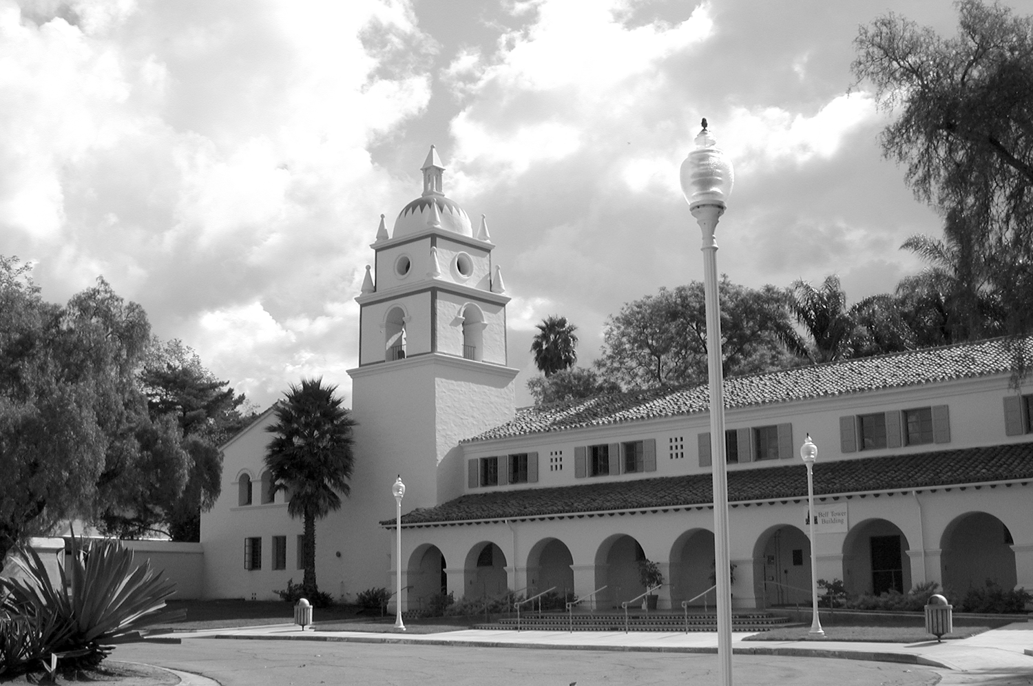

Archivist: Evelyn Taylor
Location: Library, One University Drive, Room 1082 Camarillo, CA 93012
Phone Number: (805) 437-8830
E-Mail: evelyn.taylor@csuci.edu
Hours of Operation: 9:30 a.m. – 5:00 p.m., Mon. – Fri. Generally
(Due to limited seating, research appointments
must be scheduled 24 hours in advance.)
the CAMARILLO STATE HOSPITAL collection
1936-1997

A LITTLE BIT OF HISTORY
When the United States took possession of California and other Mexican lands in 1848, it was bound by the Treaty of Guadalupe Hidalgo to honor the legitimate land claims of Mexican citizens residing in those captured territories. The land upon which the former Camarillo State Hospital sat, once belonged to Isabel Yorba as part of an 1836 land grant, known as “Rancho Guadalasca.”

In 1929, the California legislature initially appropriated $1,000,000 for the purchase of land and buildings to be utilized for a state hospital. Three years later, 1500 acres of the 8600 acre Lewis Ranch, owned by agriculturists Joseph P. Lewis and Adolfo Camarillo, located within the City of Camarillo, County of Ventura was acquired for $415,000.

Architectural plans for the new hospital were rushed to state architect, George McDougall, to begin the process to accommodate the initial 3000 patients for the first unit. The hospital was expected to cover 200 acres with supply wards, homes for the superintendent and officials, dormitories for employees and patients, commissaries, and storerooms. It was anticipated that the completed hospital would house 7000 patients and over 700 staff.

The first artist rendition of the hospital appeared in The Camarillo News on November 25, 1932. Fifty male patients arrived in Camarillo in March of 1933, and were initially housed in the farm home on the Lewis Ranch. That number grew to over 100, in June of 1934. A call for construction bids came from the State in May of 1933 and during that same month, Camarillo State Hospital or “CAM” as it was named affectionately by its employees, received its official name. Camarillo State Hospital officially joined six other state institutions, with 16,000 patients between them, under the direction of Dr. J.M. Toner.

Units 1 and 5 of the initial section of the hospital were scheduled for the first construction. The WPA project began. The groundbreaking ceremony took place on August 15, 1933, with Josephine Lewis, Mr. and Mrs. Adolfo Camarillo, Governor Rolph, and Dr. Toner in attendance. The new hospital project was a direct result of an agreement between the Public Works Administration and the State of California. The total amount of the construction cost was approximately $10,000,000 and at completion, was the largest mental hospital in the world.

In April of 1936, Thomas W. Haggerty, physician, surgeon, and psychiatrist was hired as the new Superintendent for the hospital. However, the hospital didn’t officially open for the mentally disabled until October of that year. The official opening brought Governor Frank Merriam, who made the dedicatory address; Adolfo Camarillo; Joseph McGrath; Ed Rains; Roy Pinkerton; and other local celebrities.

The first official hospital patients were adult men, who were housed in the Bell Tower (South Complex). In 1937, 300 women patients were transferred to Camarillo from other state hospitals. In fact, there were so many patient transfers from other overcrowded state hospitals, that a North Complex was initiated in 1939. The South Complex and the North Complex were then divided into male and female wards.

In 1947, Camarillo State Hospital opened a ward for the admission of mentally disabled children. When this ward expanded, a Children’s Treatment Center was constructed and occupied in January, 1955. The facility grew with a new Receiving and Treatment Center and an Administration Building in 1949. Staff population at this time was around 1518. In 1957, the patient population reached its peak, exceeding 7,000, the largest population that the hospital would see in its 60 years of existence.

Prior to 1959, adolescent males and females were housed with mentally disabled adults. In 1959, the adolescent females (including autistic patients) were separated from their adult counterparts. By 1968, the Adolescent Division was separated from the Children’s Division and organized into four treatment units and a special school. In 1970, the units became co-educational.

The hospital began its double duty in 1967, when its role as a mental hospital for illnesses such as schizophrenia or manic depression, was widened to include a center for clients with developmental disabilities, such as organic brain disease, autism, and other birth defects that limit the ability to learn.

In 1969, the Lanterman Petris Short Act became effective, which eliminated the previous indefinite commitments of persons found by a court to be mentally disabled. The new law required an automatic judicial review of every decision to hospitalize a person involuntarily beyond a very limited time. The law also required annual reconsideration of involuntary treatment. State agencies encouraged outside placement of individuals under the Penal Code, which in turn, led levels of care or services at state hospitals to decrease, while costs of care increased.

In 1971, the CAM treatment staff was reorganized under a program management concept, which enabled the establishment of treatment programs for persons with similar needs. Each treatment program was headed by a program director/mental health professional. Later, in 1976, the reorganization of the hospital led to the establishment of an Executive Director, who appointed a Clinical Director, Medical Director, and Administration Services Director for the hospital. Discoveries regarding chemical barriers in the brain created a new generation of drugs, which enabled a mentally disabled person to live a normal life. After forty years, the “mental hospital” role of CAM dwindled.

In 1983, an innovative approach to treatment for the mentally disabled was initiated at CAM. Activity centers allowed adult patients to be placed in a day treatment location, away from the living units. Patients were allowed to leave their living units at various times of the day and evening to attend therapy groups, activity groups, and educational programs. These programs were refined to include the latest biopsychosocial treatment approaches developed by U.C.L.A. at the Camarillo State Hospital Research Center. The scheduling of patients into groups, based on their needs and strengths, allowed for the most individualized treatment available in the history of the facility.

In 1985, a new vision and role for the hospital was imagined: “Enhancing Independence Through Innovation”. CAM evolved from a one-time locked down, lifetime institution for the severely
mentally ill into a facility which provided innovative and successful treatment modalities for drug and alcohol abusers, as well as programs that stabilized the mentally and developmentally disabled and successfully returned them to society. For many years, the hospital remained independent and autonomous from the outside world, with its own gardens, ice house, dairy, butcher, fire and police departments, hospital, beauty parlors, petting zoo, clothing store, swimming pool, and bowling alley. It even housed staff on its grounds. With its accreditation ratings consistently high in the 1980s and 1990s, the hospital seemed destined to last forever.

Unfortunately, that was not to be the case. The closure of CAM is a complicated issue and not easily answered. Ultimately, it was the end result of economic strain and a changing outlook on mental health. On May 17, 1996, Governor Pete Wilson empowered a special task force to research reasons for and against the closure of the Camarillo State Hospital and Developmental Center. The task force cited that the facility, which housed as many as 7,266 patients in 1954, had only 871 clients in 1996. Its per capita costs had risen to nearly $114,000, second highest in the state mental health system. These factors prompted the initial closing of one-quarter of the facility’s 64 units and later, on June 30, 1996, CAM officially and permanently closed its doors to the public.

OUR COLLECTION
California State law does not allow confidential and restricted information to be released to any party, other than the subject, without authorization or subpoena. Furthermore, no documentation whatsoever related to particular patients is located in the collection. Patient files either followed the patient to another facility or were forwarded on to the California Department of Developmental Services, if the patient was discharged or passed away. For more information about the California Department of Developmental Services which oversaw the administration of Camarillo State Hospital, please see its website at http://www.dds.ca.gov/siteindex/site.cfm.

The CSH collection here at CSUCI, although small, is notably unique, for it is both an original and an artificial gathering of materials - a mixture of hospital-generated materials and archive-generated documents created by and for various departments and individuals related to the hospital. It contains a variety of items left behind in and among the swirling halls and rooms of the great proximity, buried underneath discards and clutter when the hospital shut its gates, only to surface later with the help of former employees and university personnel, who understood the deep significance of its place in both California and Camarillo history.

The materials are separated initially by date, for example: pre-hospital years, hospital years, and post-hospital years and are further divided into general topics. The first record group, entitled “Hospital History” provides the most valuable and functional information in the collection. It contains a variety of items, such as correspondence, brochures, manuals, newsletters, newspaper articles, speeches, and even information about books written about the hospital or movies which utilized the hospital grounds for background scenery. For information on this and additional record groups in the collection, please contact the archivist.

Information may be found in our substantial collection of some of the earliest and most recent newspaper articles (1926 to 2001) about the hospital, from the Camarillo, Oxnard, and Los Angeles prospective. We have approximately 300 photographs of the hospital and its grounds, dating back to the 1930s. The photographs can be viewed via the library webpage at: http://www.flickr.com/photos/csu_channel_islands/collections/72157625225400533/. Photos are not for sale or reprint at this time; however, they can be found at the California State Archives, located at 1020 "O" Street, Sacramento, CA 95814, (916) 653-7715. The photo collection is entitled the “WPA Collection; in particular, the Durkee Collection”, numbers F3253.90-F3253.94. You can review old CSH newspaper articles, via the library newspaper database webpage for “Los Angeles Times Proquest Historical Newspapers”: https://search-proquest-com.summit.csuci.edu/publication/55410?accountid=7284&OpenUrlRefId=info:xri/sid:primo

We also recommend that you set aside an hour to watch a highly informational DVD about the hospital, which was compiled, edited, and produced by CSH staff in 1997. The DVD is available for viewing in the archives.

WHY SHOULD I BE INTERESTED?
A library houses books, which by nature, are mass produced, edited, and usually composites of numerous works. An archive maintains documentation which is predominantly unique, unpublished, and irreplaceable, in both form and substance. The majority of materials found in an archive are considered to be primary sources - those which provide individual first-hand knowledge, research, and/or documentation of events, personalities, and even social topics and issues of concern at the time.

IS A FINDING GUIDE AVAILABLE?
Please feel free to stop by and tour the archives. We are always available to answer any questions regarding the collection via telephone or e-mail and will make every attempt to accommodate your research needs. A Finding Guide is available in Word format, which can be sent via e-mail, as well as general information on how to use the archives (including tips and “Dos and Don’ts”).

CSUCI ARCHIVES

RESEARCHER CHECKLIST
FOR MATERIALS IN THE
CAMARILLO STATE HOSPITAL COLLECTION

What are you interested in?

Admission Procedures ___
Building Functions and Locations ___
Closure
General ___
CSU Task Force ___
Community Involvement ___
Events (openings, anniversaries, speakers) ___
Famous or Noteworthy Patients ___
Fiscal Information ___
Hospital Facts and Figures (Stats) ___
Illnesses Treated ___
Investigations (alleged illicit activity and “scandals”) ___
Movies Filmed on Grounds ___
Patient Rights: Lanterman-Petris-Short Act of 1967 ___
Pre-Hospital (Lewis family) ___
Programs and Treatments
Adults ___
Children’s Unit ___
Variety of ___
Staff (jobs and services) ___
Training Procedures ___
UCLA Clinical Research Unit ___

NOTE: The variety and amount of information that we have on each topic varies. We suggest using the historical newspaper databases and database journals (particularly, PsycInfo) to supplement any research.

THE CORRECT PROCEDURE FOR
CITING PAPERS FROM
THE CAMARILLO STATE HOSPITAL

- Collection Name and University
- Record Group Name (Ex: History Files)
- Box Number AND
- Folder Number →→ [Ex: Box 1 & Folder 7 = 1/7]
- Type of Document (Ex: Letter/Memo/Report/Article)
- Author (and Recipient if applicable) and/or Title
- Year of Document ( Ex: Feb. 1, 1980)

EXAMPLE:
*Initial Cite: Camarillo State Hospital Collection, Cal. State Univ., Channel Islands; Hospital History, 1/7; Letter to Sam Jones from Dr. Robert Stevenson; 2/1/80
OR
Camarillo State Hospital Collection, Cal. State Univ., Channel Islands; Hospital History, 1/7; Data Sheet; 2/1/8
OR
Camarillo State Hospital Collection, Cal. State Univ., Channel Islands; Hospital History, 1/7; Article: “Life at Camarillo”, Los Angeles Times; 2/1/80

*An Initial Cite is used every time a new document is mentioned in your paper.

**A Subsequent (or secondary) Cite is used after a particular document has already been mentioned. EX: CSH; History Files; 1/7; Letter to Jones; 2/1/80.

